13 Colonies

Three Regions:
- New England Colonies,
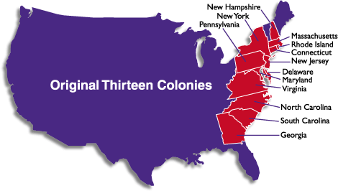
  - Massachusetts
  - Rhode Island
  - New Hampshire
  - Connecticut

- Middle Colonies (Breadbasket Colonies),
  - Delaware
  - New York
  - New Jersey
  - Pennsylvania

- Southern Colonies
  - North Carolina
  - South Carolina
  - Maryland
  - Virginia
  - Georgia

To the tune of Lorde’s “Royals” (2013)
Let's talk about the 13 colonies...
You know it all started 'cause of greed, they wanted money
And I'm not proud of what they did
But I know my facts,
And that's why I'm singing...
New England Colonies:
Massachusetts, founded as two colonies,
Plymouth colony started 1620,
Pilgrims.. On a ship called the Mayflower
And the other one:
Massachusetts Bay was the other MA colony
Winthrop & the Puritans, happened 1630
Yeah, we care, & now this is our time to share
It’s the thirteen colonies
Regions separated into three
New England and the Middle too
The third is Southern, it is true
North American Eastq Coast,
People fighting over all the land
And baby, they ruled
This is the thirteen colonies
Pilgrim really means separat...ist
They didn't like the rules and so they moved to America
Connecticut, Rhode Island, and New Hampshire
are the other three... New England Colonies
And then the Middle ones:
Delaware, New York, New Jersey, Pennsylvania
Land was fertile, lots of crops and oh yeah
Just these four... But just you wait, 'cause you know there's more
There's also Southern ones:
NC, SC, Maryland, and Virginia
One more for ya; did you know it's Georgia
Several fights... But they still liked their trading rights
CHORUS
Oh, oh, oh
French, Spanish, and the English
Explorers, European
Oh, oh, oh
And then the first Americans...
They were native and had other plans
CHORUS

