Name: ________________________ Date: __________________ Homeroom: _________________
Name: ________________________
Revolutionary War &
Black History Newspaper Project
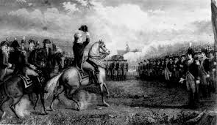 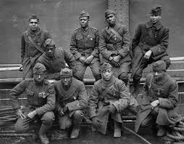
Your assignment is to work with a partner to create a newspaper about the Revolutionary War. You will feature an article on an African American soldier. You and your partner will be assigned to research a specific time period (for example, the Battle of Concord or Lexington) and the name of an African American who fought the war. You will write about the events in reporting style, news features, obituaries, and opinion pieces.
New events may include eyewitness accounts of events like the Boston Tea Party or the Crossing of the Delaware. You may even draw political cartoons.

Be sure to include:
- Time Period Name: __________________________________________________
- Date: _______________________________________________________________
- Setting: _____________________________________________________________
- Key People: _________________________________________________________
_____________________________________________________________________
- Other Pertinent (Important) Information: ______________________________
_______________________________________________________________________________________________________________________________________________________________________________________________________________

(Some) African Americans &
The American Revolution
- James Armistead
- Peter Salem
- Henri Christophe
- William Flora
- James Forten
- Jack Sisson
- Colonel Tye
- Phillis Wheatley
- Prince Whipple
- Elizabeth Freeman
- Lemuel Hayes
- Saul Matthews
- Thomas Peters
- Salem Poor
- Crispus Attacks
- Agrippa Hull
- Peter Williams
- Oliver Cromwell
- Jordan B. Nobel
- Caesar Augustus

