Nervous System Notes
- Review Nervous System Glossary
- Review videos on website
- Write down any questions you have or email them to Ms. Casey.

Nervous System Big Ideas:
- Two main systems:
  - Central Nervous System – brain
  - Peripheral Nervous System – spinal cord and rest of body
- Other system:
  - Autonomic Nervous System – automatic responses (i.e. if you are itchy and scratch without “thinking” about it…)

- Two types of nerves:
  - Sensory nerves – nerves with which you sense feelings; your nerves SEND these messages to the brain
  - Motor nerves – nerves by which your brain sends messages to other body parts. (Think motor = go; your brain tells your body part to “go”. It is also helpful to think of your brain as the motor…)

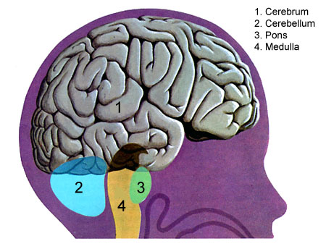
- Three major parts of your brain:
  - Cerebrum – the largest part of your brain (THINK: See the two r’s and the b? Remember, really, really big); imagination and thinking…
  - Cerebellum – just above the brain stem; helps with balance (THINK: “bell-ance” might help you remember balance, also the two “l”s look like legs!) and new learning
  - Medulla – brain stem; controls involuntary functions like breathing…

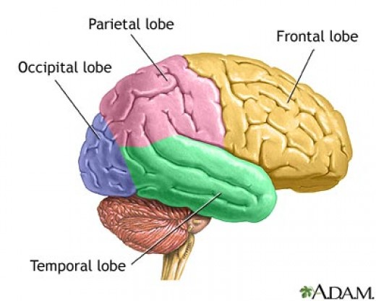
- Four lobes of the brain (THINK: F-TOP):
  - Frontal – personality and emotions
  - Temporal – hearing and organizational skills (THINK: It’s actually between your ears… that should help you remember its function!)
  - Occipital – vision (THINK: Ever hear a teacher/parent say they had eyes in the back of their head? Good way to remember its placement. Also, there are two “i”s in occipital. Similarly, there are two EYES in your head!)
  - Parietal – sense of touch and hand movement

It’s the Nerve
http://www.teachertube.com/viewVideo.php?video_id=262902

This is the Nervous System
It is a network of many nerve cells
That together work
Carry, carry messages fast as lightning
Through your whole body
Don’t even feel a thing

Every single thought and every action
Every reflex and reaction is caused by
Interaction that results from the Nervous System
(It’s the, it’s the nerve…
The Nervous System, the Nervous System…)

Brain, your spinal cord, and your nerves
Are connected together
And together they work
It’s very complex
More than any object

A stimulus is when you feel something hot
The sensory receptors in your hands feel it a lot
A signal goes through, sensory neurons now
Through, up the spinal cord without a sound

The same note is in the spinal cord
The motor norm, the muscle it travels toward
(Now you pulled back, you pulled back real fast)
Because you didn’t expect…
Ladies and gentleman, that was a reflex
(Oh…)

This is the Nervous System
It is a network of many nerve cells
That together work
Carry, carry messages fast as lightning
Through your whole body
Don’t even feel a thing

Every single thought and every action
Every reflex and reaction is caused by
Interaction that results from the Nervous System
(It’s the, it’s the nerve…
The Nervous System, the Nervous System…)

