December 4, 2013
Human Body Systems
Musculoskeletal Notes
(Taken from SMARTBoard Presentation Reviewed In Class)
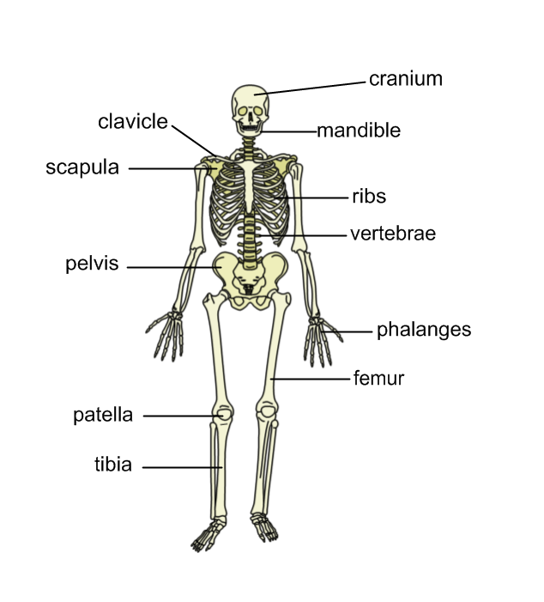
Three Functions of the Skeletal System:
- Support
- Protection
- Movement
Three Types of Muscles:
- Skeletal
- Smooth
- Cardiac

Skeletal Muscles…
- Are attached to your bones
- Allow you to move and be active
- Are made stronger with exercise
- Can be controlled
- Allow you to decide when to move
Smooth Muscles…
- Are found in organs
- Operate automatically all the time (involuntary function)
- Your lungs and diaphragm move when you breathe because your brain sends signals to smooth muscles without you having to “think” about it.

Cardiac Muscles…
- Are only found in your heart
- Are extremely strong
- Work all the time
- Work involuntarily (without you thinking about it)
Movement
Unique
Smooth
Cardiac
Life
Everything
Skeletal

Vocabulary!
- Smooth muscle – muscles found in organs such as your lung and stomach
- Musculoskeletal – your bones and muscles working together
- Cardiac muscle – muscle found only in the heart
- Skeletal muscle – muscle attached to your bones
- Skeleton – the framework of your bones (main functions: support, protection, and movment)

Three Types of Blood Vessels
- Arteries
- Veins
- Capillaries

