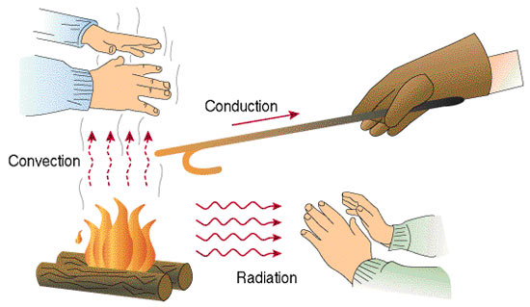

Motion & Design
Heat Transfer

Heat Transfer | Definition | Examples
Conduction | Heat transferred by the direct contact of molecules | - A pot sitting on a hot burner rises in temperature  - A metal spoon that is sitting in a pot of boiling water gets hot  - A heated blanket to gets a person warm  - A cup of hot coffee burns a person.  - Ice is held in a person’s hand and begins to melt.
Convection | Heat transferred through a liquid or gas by means of up-and-down (heat rises, cools, then falls) | - An old-fashioned radiator emits warm air at the top vent in a room and draws in cool air at the bottom.  - A hot air balloon rises a torch pushes hot air into the balloon and cool air falls out of the bottom.  - The surface of the ocean is much warmer than the depths of it. The more shallow the water, the warmer; the deeper the water, the cooler.
Radiation | Heat transferred through an empty space by invisible infrared rays | - A person’s hands get warm next to a campfire  - A person lays on the beach to get a tan/take a nap in the warm sun  - A lightbulb is warm-to-touch.
The Heat Beat
(Convection, Radiation, Conduction Rap)

Convection, convection
This is my confession
The cool air moves down and warm, the up direction

I like the radiation of the sun’s sensation
It’s all about the waves,
That move in every nation

I’ll tell you ‘bout conduction
This is how it functions:
Heat travels through a solid
Now you ought-a know, son!

CON.. VEC… TION
And radiation
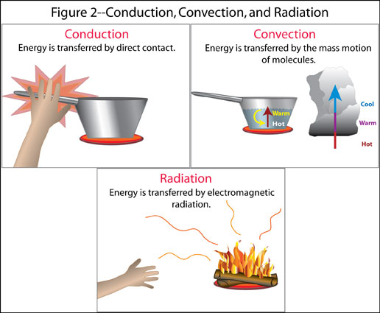
CON… DUC… TION
In every nation!

