Ecosystems Standards
Essential Standards &  Clarifying Objectives |  |  | Unpacking the Standards
5.L.1 Understand how structure and systems of organisms (to include the human body) perform functions necessary for life.
Explain why some organisms are capable of surviving as a single cell while others require many cells that are specialized to survive. | 5.L.1.1 | - Unicellular organisms, such as algae, consist of a single cell and perform all life processes within a single cell.  - Multicellular organisms are organisms that consist of more than one cell and have differentiated cells that perform specialized functions in the organism.
5.L.2 Understand the interdependence of plants
and animals with their ecosystem.
Compare the characteristics of several common ecosystems, including estuaries and salt marshes, oceans, lakes and ponds, and grasslands. | 5.L.2.1 | - There are different types of ecosystems (terrestrial and aquatic).  - Students know typical visual representations of the various ecosystems, as well as graphic representations of the food chains and webs, cycles and energy pyramids that are commonly associated with ecosystems.
Classify the organisms within an ecosystem according to the function they serve: producers, consumers, or decomposers (biotic  factors). | 5.L.2.2 | - Organisms can be producers, consumers, or decomposers.  - Producers convert energy from the sun into organic matter through photosynthesis.  - Producers and consumers use energy for basic life purposes.
Infer the effects that may result from the interconnected relationship of plants and animals to their ecosystem. | 5.L.2.3 | - All of the organisms in an ecosystem have interconnected relationships. Because of this, factors that impact one population within an ecosystem may impact other populations within that ecosystem.
4.L.1 Understand the effects of environmental changes, adaptations & behaviors that enable animals to survive in changing habitats.
Explain how humans can adapt their behavior to live in changing habitats (e.g., recycling wastes, establishing rain gardens, planting trees & shrubs to prevent flooding and erosion. | 4.L.1.3 | - Humans can adapt their behavior in order to conserve the materials and preserve the ecological systems that they depend upon for survival.
5.P.3 Explain how the properties of some materials change as a result of heating and cooling.
Explain the effects of the transfer of heat (either by direct contact or at a distance) that occurs between objects at different  temperatures (conduction, convection, radiation). | 5.P.3.1 | - Radiation is the transfer of energy by electromagnetic waves. Electromagnetic waves can carry energy through places with or without any matter.  - The Sun is the main source of electromagnetic energy on Earth. Part of this energy, light, is used by producers to make food.
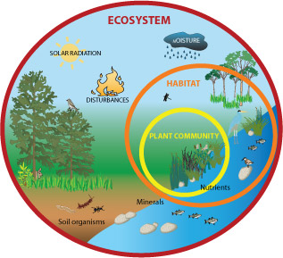
Ecosystems Notes
Ecosystem – all the living (biotic) and nonliving (abiotic) things in a particular area.
- Examples of ecosystems:
  - Fish bowl
  - Tree
  - Tundra
  - Deciduous Forest
  - World
  - Farm

Two Types of Ecosystems:
Terrestrial (Land) | Aquatic (Water)
- Rain forest  - Deciduous Forest | - Lakes and ponds (freshwater)  - Oceans (saltwater)

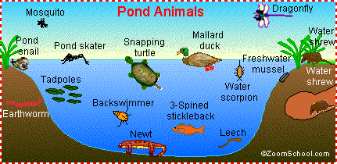
More Facts about Ecosystems:
- The temperature of an ecosystem depends on how close it is to the equator.
- All of the organisms in an ecosystem have interconnected relationships! Because of this, when one population is affected, others will be affected. (Cause and effect, Action and reaction.)

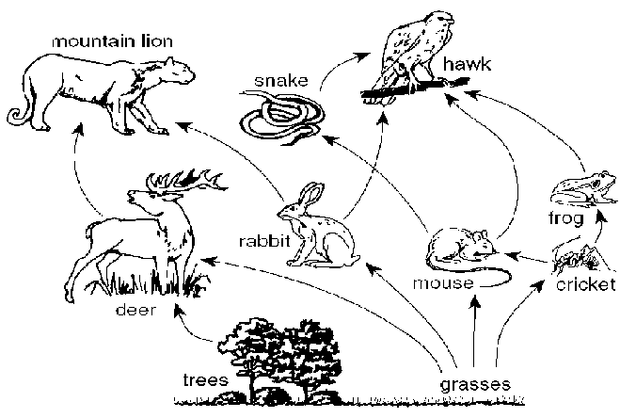
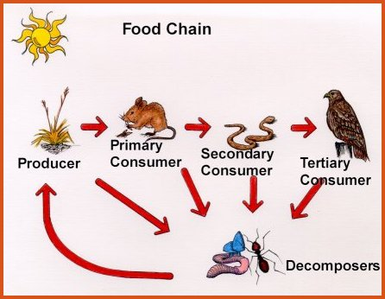
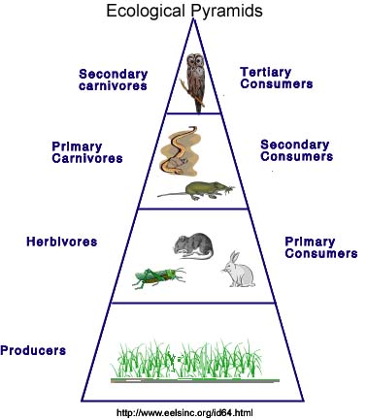
Food Chain
Food Web

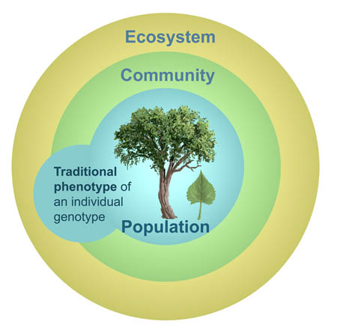
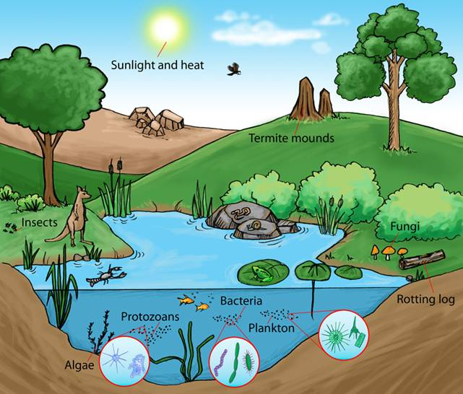
Individual – one organism
Population – all the members of one species in an area
Community – all the living things in an ecosystem
Ecosystem – all the living and nonliving things in an area
Biome – regions of the world with similar climate (weather, temperature), animals, and plants.
Biosphere – all trees and life; includes hydrosphere (water) and atmosphere (sky)
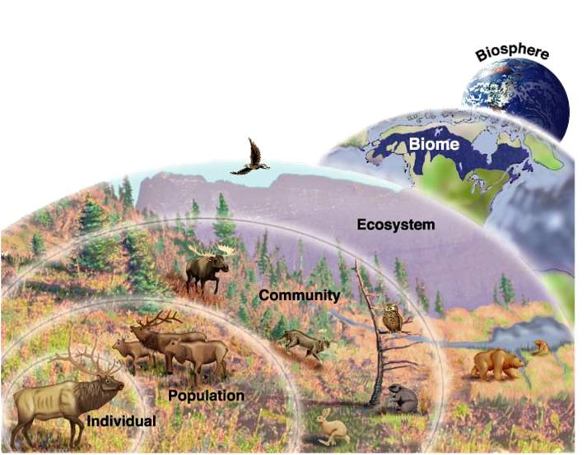
Well-Known Biomes
- Tropical Rainforest
- Tropical Savanna
- Desert
- Mediterranean Woodland
- Mid-latitude Grassland
- Mid-latitude Deciduous Forest
- Tundra
- Ice Caps
Needs of Organisms
For organisms to stay alive
They need five things, I would not lie
ENERGY to make or eat
Then WASTE whatever they don’t need
LIFE THINGS, 1-2, FIVE NEEDs, 3-4
They REPRODUCE and also GROW
RESPOND to what’s around like so…
LIFE THINGS, 1-2, FIVE NEEDS, 3-4
http://kids.nceas.ucsb.edu/biomes/
http://www.geography4kids.com/files/land_ecosystem.html
Fancy Organisms
To the tune of “Fancy” by Iggy Azalea
Organisms
You already know
Living things that carry life out on their own
Organisms
Many cells or one
Remember what makes
Them grow

Five things, five things
Give them life (Yeah, that’s right)
x2

Choose TWO questions to answer in COMPLETE SENTENCES.

- What is an ecosystem?

- Name and describe some ecosystems.

- Explain whether there would be more or fewer organisms as you move up the levels of a tropical rain forest energy pyramid.

- Compare food chains and food webs and give an example of each.

- What are the five characteristics of organisms?

Types of Organisms
Producers | Consumers | Decomposers | Scavengers
Plants; produce energy from the sun through photosynthesis. | There are primary (1st), secondary (2nd), and tertiary (3rd or more) consumers; consume energy by eating/drinking. | Bacteria, fungi, worms, etc.; eat dead organisms and restore useful nutrients (like nitrogen) back to the soil. | Eats decaying organic matter.
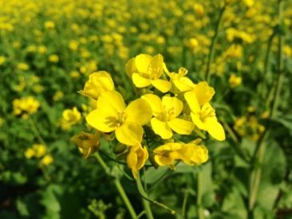 | 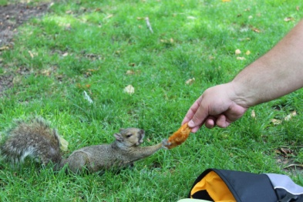 | 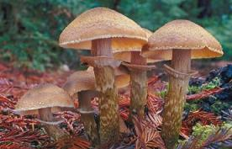 | 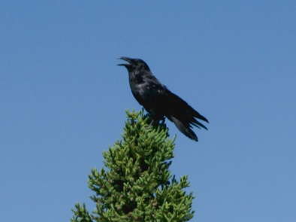
“Producers are the plants and like photosynthesis – the light, that’s right.” | “Consumers eat the plants and more – herbi-, carni-, omnivores.” | “Decomposers eat the dead, put the good stuff in the plant bed... Nitrogen… Nitrogen.” | “And scavengers eat what’s left…”

What are some causes of extinction?

Why is conservation important?
Niche: the role of an organism in an ecosystem; its job
Overpopulation: too many of at least one kind of living thing in an area compared to the available resources
Competition: the struggle among organisms for water, food, and other needs
Resources: things organisms need for survivalfood, water, shelter
Extinct: a species that has died out completely
Endangered: a species that is in danger of becoming extinct

http://farm4.staticflickr.com/3310/3666168483_8f3c3fb624_o.jpg
https://media.studyisland.com/pics/18347Decomposer.jpg
http://upload.wikimedia.org/wikipedia/commons/d/de/20120623_Sqwiki_the_Squirrel_at_Wiknic.JPG
http://upload.wikimedia.org/wikipedia/commons/4/46/Punjabi_Mustard_Flowers.JPG

Ecosystems Song

Producers are the plants and like photosynthesis – the light, that’s right.

Consumers eat the plants and more –
Herbi-, carni-, omnivores.

Decomposers eat the dead,
Put the good stuff in the plant bed... Nitrogen… Nitrogen,

And scavengers eat what’s left…

Changing Ecosystems
Vocabulary
Ecology | The study of how living and nonliving things interact. | Ex. Going outside to study plants; documenting findings.  Ex. Jamie studying ecosystems in Ms. Casey’s class.
Succession | The process by which new organisms replace old organisms. | Ex. A tree dies and a new tree grows in its place.  Ex. A flower dies and a new one grows in its place.  Ex. The grass and bushes were moved so that the Northwoods Garden could be planted.
Conservation | The wise management and use of natural resources.  (Conserve means to save or use well…) | Ex. Turning off water when you’re not using it.  Ex. Turn off lights when you leave the room.  Ex. Try not to use as much water.  Ex. During WWII, people had to use rations for supplies.

Human Effects on the Environment
Positive + | Negative -
- Give animals a place to live  - Using less resources  - Reforestation (replanting trees and planting seeds)  - Growing seeds  - Creating habitats  - Help prevent natural disasters  - Save animals  - Recycling  - Using less trash or plastic  - Planting plants in a garden and establishing an ecosystem | - Animals are taken out of their habitats and placed in captivity  - Pollution  - Coral Bleaching  - Oil spills  - Smoking  - Hurt animals  - Hunting  - Poaching  - Deforestation (cutting down trees/forests)  - Littering

Cells: The Building Blocks of Life

- Smallest unit of living things…
(Atoms make up ALL things; including cells!)
- Each human has 75 trillion cells!
- Single celled organisms…
  - Carry out all necessary functions in one cell
  - AKA (also known as): unicellular
  - Examples: bacteria, amoeba
  - PROKARYOTIC
- Multi-celled organisms…
  - Operate because of specialized functions (the cells have different jobs and work together to get the job done)
  - Usually have moving parts
  - Examples: plants, animals, fungi
  - EUKARYOTIC

