Earth’s Lines
Written by Lizzie Casey
Taught with NC Essential Standards for Grade 5 Science in the Weather Unit
5.E.1 Understand weather patterns and phenomena, making connections to the weather in a particular place and time.

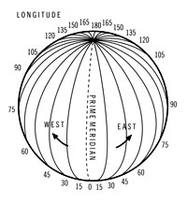
Longitude and Latitude
[Open arms vertically for longitude and horizontally for
latitude. Clap with the cadence of the rhyme.]
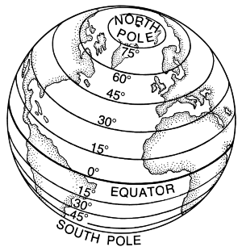
Prime Meridian
[Open arms vertically for Prime Meridian.
Clap with the cadence of the rhyme.]

Equator is the hottest point
[Open arms horizontally for equator. Clap with the cadence of the rhyme.]
Direct light from the Sun
[Point to the Sun.]

