18th Century
American Revolution
Dates: 1775 - 1783
Where: Eastern seaboard of North America
How It Ended: The Treaty of Paris was signed on Sept. 3, 1783
American Battle Deaths: 4,435 (approx.)

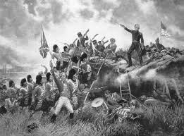
19th Century
War of 1812
Dates: 1812 - 1815
Where: Canada, Eastern seaboard of the United States,
Great Lakes and Lake Champlain
How It Ended: The Treaty of Ghent was signed on Dec. 24, 1814. Unaware of the treaty, Gen. Andrew Jackson engaged and crushed the British at the
Battle of New Orleans on January 8, 1815.
American Battle Deaths: 2,260 (approx.)
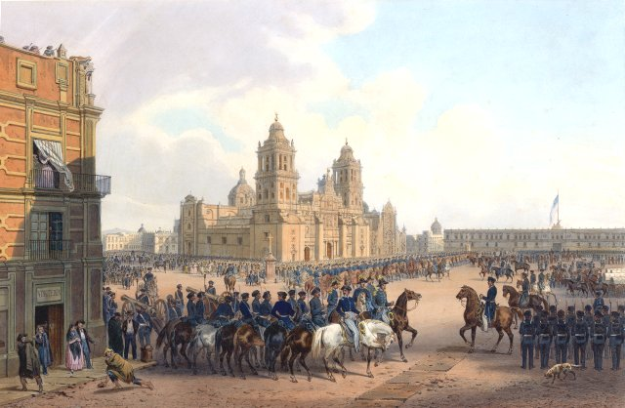
Mexican-American War
Dates: 1846 - 1848
Where: Mexico and southwestern United States, including modern-day Texas, California and New Mexico
How It Ended: The Treaty of Guadalupe Hidalgo
was signed on Feb. 2, 1848.
American Battle Deaths: 1,733 (approx.)
Civil War
Dates: 1861 - 1865
Where: Primarily in the Eastern half of the US (east of the MI River)
How It Ended: Robert E. Lee surrendered to Ulysses S. Grant at the small settlement of Appomattox Court House
in southwestern Virginia on April 9, 1865.
American Battle Deaths: Union forces 140,414 and
Confederate forces 74,524 (approx.)
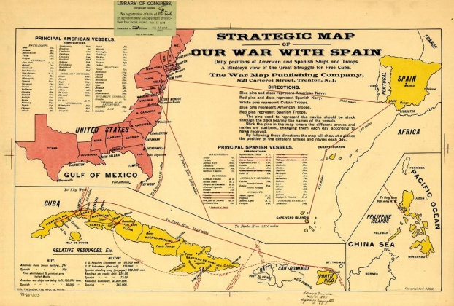
Spanish-American War
Dates: April 25 - Aug. 12, 1898
Where: Mainly in the Spanish possessions
of Cuba and the Philippines
How It Ended: The Treaty of Paris was
signed on Dec. 10, 1898.
American Battle Deaths: 385 (approx.)

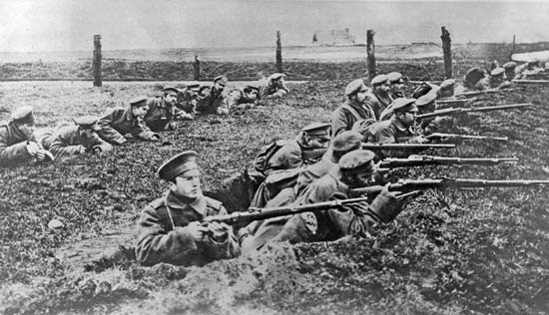
20th Century
World War I
Dates: 1914 - 1918
Where: The Atlantic Ocean and Europe
How It Ended: Treaty of Versailles
was signed on June 28, 1919.
American Battle Deaths: 53,402 (approx.)
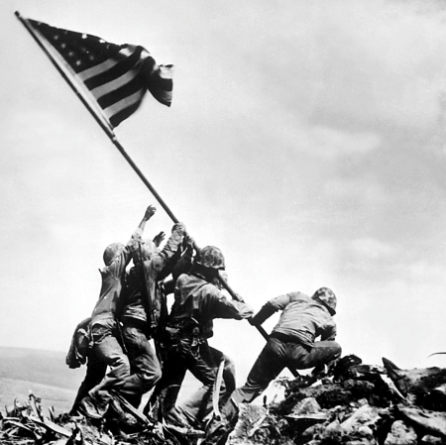
World War II
Dates: 1939 - 1945
Where: Europe, North Africa, Asia, Australia, and Pacific Islands
including Hawaii, Atlantic and Pacific Oceans
How It Ended: Japan was the last Axis power to surrender
on August 14, 1945, after the U.S. bombing of Hiroshima and Nagasaki
American Battle Deaths: 291,557 (approx.)

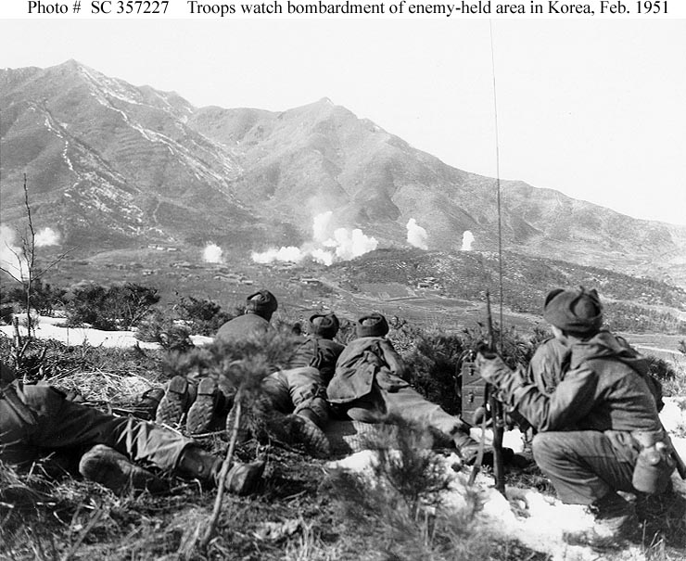
Korean War
Dates: 1950 - 1953
Where: North and South Korea
How It Ended: The war reached a stalemate
in June 1951. An armistice was finally reached on July 27, 1953.
American Battle Deaths: 33,741 (approx.)
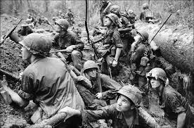
Vietnam War
Dates: 1954 - 1975
Where: Southeast Asia
How It Ended: The U.S. withdrew after a ceasefire in 1973.
North Vietnam proved victorious with the Fall of Saigon in April 1975.
American Battle Deaths: 47,424 (approx.)
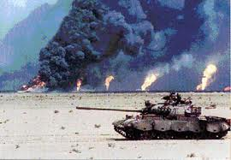
Persian Gulf War
Dates: August 1990 - April 1991
Where: Iraq and Kuwait
How It Ended: After a four-day ground war, an American-led coalition declared victory. A cease-fire
agreement was signed on April 9, 1991.
American Battle Deaths: 147 (approx.)

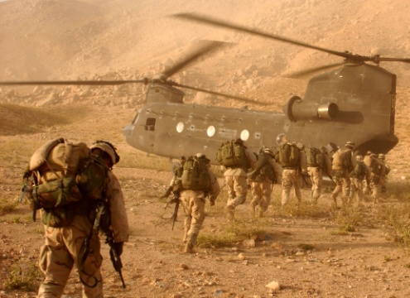
21st Century
War in Afghanistan
(Operation Enduring Freedom)
Dates: Oct. 7, 2001 - Conflict continues...
Where: Afghanistan.
American Battle Deaths: more than 2,000 to date

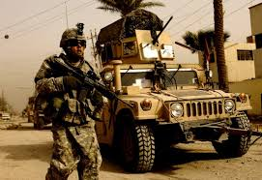
Iraq War
(Operation Iraqi Freedom)
Dates: March 19, 2003 - Conflict continues...
Where: Iraq
American Battle Deaths: more than 4,400 to date

Information:
http://www.history.com/topics/americas-wars

Pictures:
http://www.neh.gov/files/imagecache/explore_large/explore/images/washingtoncrossingdelaware.jpg
http://img.tfd.com/WEAL/weal_10_img1850.jpg
http://upload.wikimedia.org/wikipedia/commons/b/bc/Mexico_nebel.jpg
http://ipadinsight.wpengine.netdna-cdn.com/wp-content/uploads/2012/09/Civil-War-1863-for-iPad.jpg
http://www.history-map.com/picture/000/pictures/American-Spanish-Map-War.jpg
http://media-3.web.britannica.com/eb-media/51/135151-004-0D4D550E.jpg
http://cloud-3.steampowered.com/ugc/902125486839609753/AFE3EAA2BA56AC786431431295819173C2B3C107/
http://www.history.navy.mil/photos/events/kowar/51-stab/51-stab.htm
http://media.sacbee.com/static/weblogs/photos/images/2010/apr10/vietnam_sm/vietnam_sm07.jpg
http://www.usace.army.mil/portals/2/siteimages/120123-M-LC381-044.jpg
http://digitaljournal.com/img/9/2/1/3/9/6/i/5/4/2/o/us_soldiers_in_afghanistan.jpg
http://www.theamericanconservative.com/wp-content/uploads/2013/03/2383155092_7fe5e935dc_b.jpg

