Lines of Latitude, Longs of Longitude
Sung to the tune of “Wheels on the Bus”
www.SuperTeacherStuff.com

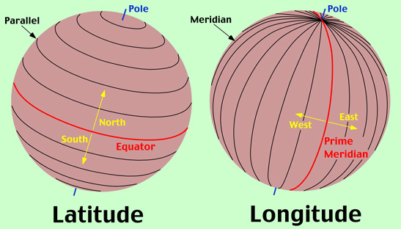

The EQUATOR is the
Starting Point
Starting Point
Starting Point
The EQUATOR is the
Starting Point
For lines of latitude

LATITUDE lines measure
North and South
North and South
North and South
LATITUDE lines measure
North and South
All around the world
The PRIME MERIDIAN is the
Starting Point
Starting Point
Starting Point
The PRIME MERIDIAN is the
Starting Point
For lines of longitude

LONGITUDE lines measure
East and West
East and West
East and West
LONGITUDE Lines measure
East and West
All around the world

