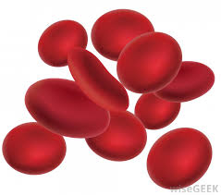
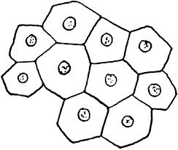
Imagine you could examine the objects and materials listed below with a powerful microscope. This powerful microscope will allow you to see evidence of cell structure. Put a checkmark next to the objects or materials that are made up (or were once made up) of cells.
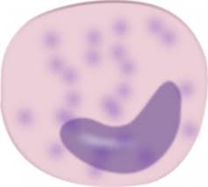

 |  | Flowers | 14. |  | Proteins
 |  | Skin | 15. |  | Rocks
 |  | Milk | 16. |  | Bone
 |  | Lungs | 17. |  | Hamburger
 |  | DNA | 18. |  | Calcium
 |  | Apples | 19. |  | Sand
 |  | Worms | 20. |  | Bacteria
 |  | Leaf | 21. |  | Seeds
 |  | Water | 22. |  | Molecules
 |  | Sugar | 23. |  | Blood
 |  | Cell Membrane | 24. |  | Mushrooms
 |  | Chromosomes | 25. |  | Saliva (Spit)
 |  | Atoms | 26. |  | Justin Beiber
Explain your thinking… Describe the “rule” or reason you used to decide whether something is (or was once) made up of cells.
____________________________________________________________________________________________________________________________________________________________________________________________________________________________________________________________________________________________________________

