Human Body
Digestive & Excretory System Notes

Mouth |  | Even before you eat, when you smell a tasty food, see it, or thinking about it, digestion begins as saliva begins to form in your mouth. As you eat, the saliva breaks down the chemicals in the food which makes the food mushy and easy to swallow.
Tongue and teeth |  | The tongue pushes food around in your mouth while you chew with your teeth. When you’re ready to swallow, the tongue pushes a tiny bit of mushed-up food called a BOLUS toward the back of your throat (pharynx) and into the opening of your ESOPHAGUS (the second part of the digestive tract).
Pharynx | Esophagus  (Digestive System) | Like a stretchy pipe that’s about 10 in. (25 cm.) long, it moves food from the back of your throat (pharynx) to your stomach.
 | Trachea  (Respiratory System) | Windpipe; allows air to come in and out of your body (inhalation).
Epiglottis |  | A special “flap” that “flops” over the opening of your windpipe when you swallow a BOLUS (small ball of mushed-up food or liquid) to make sure the food enters the esophagus and not the trachea.
Stomach |  | Like a mixer, churns and mashes together all the boluses (small balls of food) into smaller pieces with the help of the strong muscles in the walls of the stomach and gastric juices that also come from the walls. Gastric juices also help kill bacteria that might be in food.
Small Intestine |  | A long tube packed beneath your stomach about 1.5-2 inches around and if an adult’s were stretched out, it would be about 22 feet long (6.7 meters)! Breaks down the food mixture more so your body can absorb all the vitamins, minerals, proteins, carbohydrates, and fats.  (The pancreas, liver, and gallbladder help extract…)
Large Intestine |  | ALMOST the last stop on the digestive tract. It’s a long tube about 3-4 inches around and packed into the body, but would measure 5 feet (about 1.5 meters) if you spread it out. Has a tiny tube with a closed end coming off it called the appendix. When nutrients are removed from the food mixture, all the waste passes through the large intestine and into the… you guessed it…
Appendix |  | A tiny tube with a closed end attached to the large intestine. It’s a part of the digestive tract, but doesn’t seem to do anything, although it can cause major problems (like appendicitis) because it can get infected and need to be removed.
MyPlate Nutrition Information

Food Group | Portion and Function | Examples
Vegetables  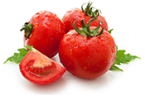  5 Subgroups of Vegetables:  Dark green, starchy, red & orange, beans and peas, and other… | Half your plate should be fruits and veggies.  May reduce risk heart disease (inc. heart attack and stroke), obesity, type 2 diabetes, high blood pressure, development of kidney stones, and bone loss. | Any vegetable or 100% vegetable juice. May be raw or cooked; fresh, frozen, canned, or dried/dehydrated; may be whole, cut-up, or mashed.
Fruits  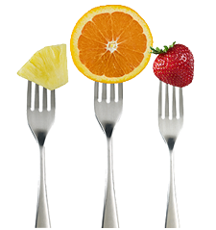 |  | Any fruit or 100% fruit juice. May be fresh, canned, frozen, or dried. May be whole, cut-up, or pureed.
Grains  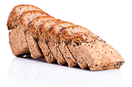  2 Subgroups of Grains:  Whole and Refined… | Very filling and good for the heart.  At least half of your grains should be whole rains (i.e. oatmeal and brown rice). | Food containing wheat, rice, oats, cornmeal, barley or another cereal grain. Bread, pasta, oatmeal, breakfast cereals, tortillas, and grits…
Protein  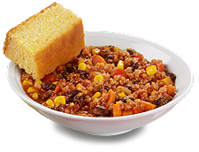 | Building blocks for bones, muscles, cartilage, skin, and blood – also enzymes, hormones, and vitamins.  B Vitamins in protein help the body release energy, support the nervous system, help form red blood cells, and help build tissues.  Include at least 8 oz. of seafood/week. | Food made from meat, poultry (chicken), seafood, beans and peas, eggs, processed soy products, nuts, and seeds.
Dairy  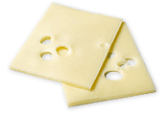 | Good for your bones and teeth.  Especially important during childhood as bone mass is being built.  Reduces risk of osteoporosis, cardiovascular disease, type 2 diabetes, and high blood pressure. | Milk (try 1% or nonfat instead of whole!), foods made from milk such as cream cheese, cream, and butter.
*Oils are included in USDA food patterns because they provide essential nutrients. Oils are fats that are liquid at room temperature (i.e. vegetable oils used in cooking) and come from many different plants and fish.

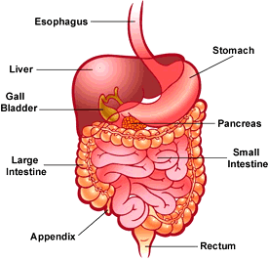
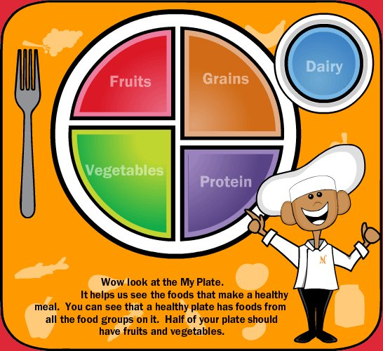

Resources:
Choosemyplate.gov
Digestive System SMARTBoard Lesson

