Convection, Radiation, Conduction

Convection, convection
This is my confession
The cool air moves down and warm, the up direction

I like the radiation of the sun’s sensation
It’s all about the waves,
That move in every nation

Let me tell you ‘bout conduction
This is how it functions:
Heat just travels through a solid
And now you ought-a know, son!

CON.. VEC… TION
And radiation
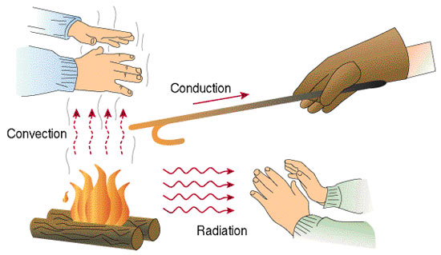
CON… DUC… TION
In every nation!

