Circulatory/Cardiovascular Notes
- Watch this video about the “bloodmobile” (AKA your body!): http://www.youtube.com/watch?feature=player_embedded&v=Futnu_6NmQo
- Review the Circulatory/Cardiovascular section of your glossary…
Blood Basics
- Two types of blood vessels carry blood throughout our bodies:
  - Arteries carry oxygenated blood (blood that has received oxygen from the lungs) from the heart to the rest of the body.
  - Blood then travels through veins back to the heart and lungs, where it receives more oxygen.

- WHERE ARE BLOOD CELLS MADE?
  - In babies and young kids, blood cells are made within the bone marrow (the soft tissue inside of bones), particularly in the long bones like the humerus (the upper arm bone) and femur (the thigh bone).
  - For older kids and adults, blood cells are made mostly in the bone marrow of the vertebrae (the bones of the spine), ribs, pelvis, skull, sternum (the breastbone).

- Blood is made up of four different components (parts):
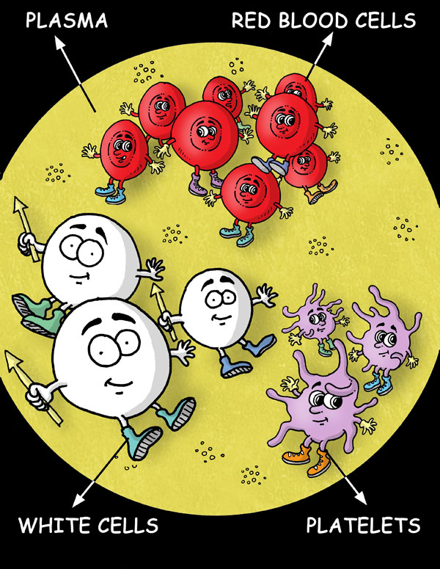
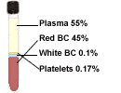
  - 55% Plasma
    - A mixture of water, sugar, fat, protein, and potassium and calcium salts. Most of plasma is made up of water (more than 92%)!
  - 40-45% Red Blood Cells (RBC)
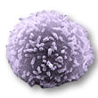
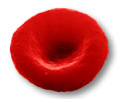
    - Contain a special protein called hemoglobin that carries oxygen from our lungs to the rest of our bodies. Hemoglobin is what makes RBCs red! We have so many RBCs that our blood itself appears red.
  - 1% White Blood Cells (WBC)
    - Clear, round cells that are bigger than RBCs. They produce proteins called ANITBODIES that help our bodies fight infections caused by bacteria, viruses, and foreign proteins.
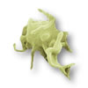
  - (100 – plasma – RBC – WBC)% Platelets
    - FRAGMENTS of cells that gather when we get injured and stick to the edges of the wound. They release chemicals that help start the process of blood clotting so the bleeding will stop!

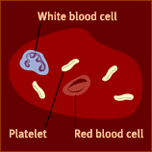

Resources:
- http://learn.genetics.utah.edu/content/begin/traits/blood/blood.html
- http://www.pbs.org/wnet/redgold/basics/whatisblood.html
- http://kidshealth.org/kid/talk/qa/blood.html

Other Notes/Drawings:

